**DAILY ONLINE ACTIVITIES SUMMARY**

|  |  |  |  |  |  |  |  |  |
| --- | --- | --- | --- | --- | --- | --- | --- | --- |
| **Date:** | **27/06/20** | | | | | **Name:** | **SARANG VK** | |
| **Sem & Sec** | **8th B** | | | | | **USN:** | **4AL16CS085** | |
| **Online Test Summary** | | | | | | | | |
| **Subject** | | **…….** | | | | | | |
| **Max. Marks** | | **……** | | **Score** | | | **……..** | |
| **Certification Course Summary** | | | | | | | | |
| **Course** | **Python for Machine Learning** | | | | | | | |
| **Certificate Provider** | | | **GREATLEARNING** | | **Duration** | | | **28 MINUTES** |
| **Coding Challenges** | | | | | | | | |
| **Problem Statement: write a c program to sort an array of integers in ascending order and display the sorted array and number of passes performed for sorting** | | | | | | | | |
| **Status:COMPLETED** | | | | | | | | |
| **Uploaded the report in Github** | | | | | **YES** | | | |
| **If yes Repository name** | | | | | **alvas-education-foundation/sarang_vk** | | | |
| **Uploaded the report in slack** | | | | | **YES** | | | |

Certification Course Details: (Attach the snapshot and briefly write the report for the same)

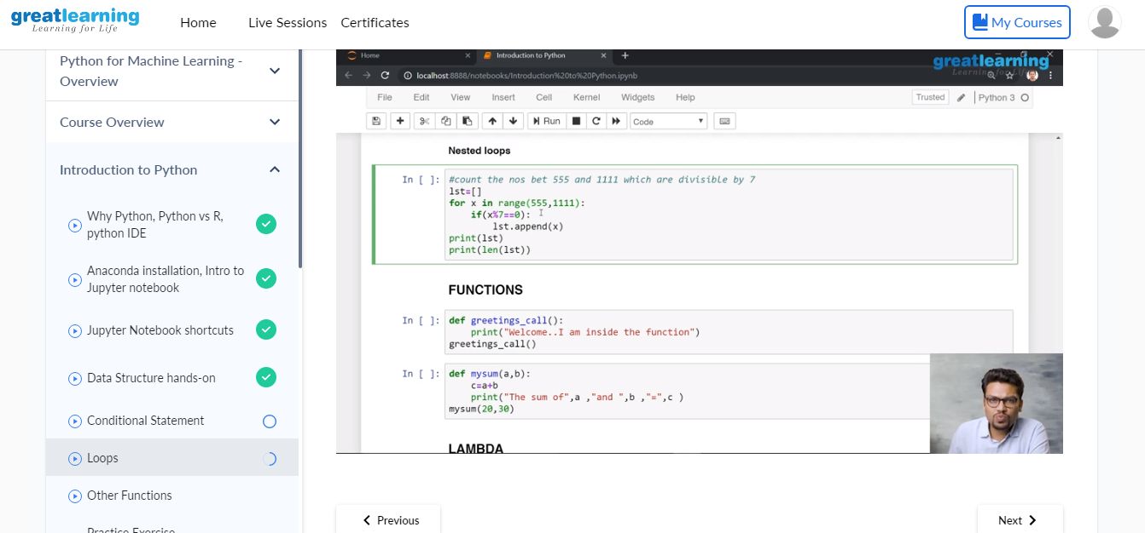

Coding Challenges Details: (Attach the snapshot and briefly write the report for the same)

Coding was given n it was uploaded for github and slack

PROGRAM1

#include <stdio.h> void swap(int *xp, int *yp)

{

int temp = *xp; *xp = *yp;

*yp = temp;

}

intbubbleSort(intarr[], int n)

{ inti, j,count=0; int swapped; for (i = 0; i< n-1; i++)

{

swapped = 0; for (j = 0; j < n-i-1; j++)

{

if (arr[j] >arr[j+1])

{

swap(&arr[j], &arr[j+1]); swapped = 1; count++;

}

}

if (swapped == 0) break;

}

return count;

}

void printArray(intarr[], int size)

{ inti; for (i=0; i< size; i++) printf("%d ", arr[i]); printf("\n");

}

intmain()

{

intarr[50],num; printf("enter the number of elements"); scanf("%d",&num); printf("enter the elements"); for(inti=0;i<num;i++){ scanf("%d",&arr[i]);

}

int c=bubbleSort(arr, num); printf("Sorted array: \n"); printArray(arr, num); printf("Number of passes:%d\n",c); return 0;

}